# Website project

***I confirm that this assignment is my own work.***

***Where I have referred to academic sources, I have provided in-text citations and included the sources in the final reference list.***



## KAPLAN INTERNATIONAL COLLEGE LONDON – IYO COMPUTER SCIENCE PROGRAMME Module Title : databases

**Module Code : IY497:P439493**

**Name : Adam Mohamed ghodbane**

**Introduction**

Welcome to our Travel Agency !

Our Travel Agency offers a seamless solution for all your travel needs, providing a one-stop platform for planning and booking your dream vacations. Designed with simplicity and efficiency in mind, our web application empowers users to effortlessly browse, select, and secure accommodations, transportation, and activities, all in one place.

Once logged in, users can explore a wide range of travel destinations and services, tailor-made to suit their preferences and budget. From luxurious resorts to cosy bed-and-breakfasts, from scenic train rides to thrilling excursions, our extensive catalogue offers something for every traveller.

Booking is a breeze. With just a few clicks, users can select their desired options and proceed to checkout. Confirmation of bookings is sent promptly via email, ensuring peace of mind and a stress-free travel experience.

Contributions from the community are always welcome. Whether you're a seasoned developer or just starting, there are plenty of opportunities to get involved. Simply fork the repository, create a new branch, make your changes, and submit a pull request – it's that easy!

For any questions, feedback, or inquiries, please don't hesitate to reach out to the Travel Agency Code Team at travelagencycode@example.com. Alternatively, visit our GitHub profile for more information and updates.

So why wait? Start planning your next adventure with Travel Agency Code today!

**Overview of the code**

Travel Agency Code isn't just a travel booking platform – it's a sophisticated web application that seamlessly integrates Flask, HTML, CSS, JavaScript, and MongoDB to deliver a dynamic and engaging user experience.

At the core of our application lies Flask, a powerful Python web framework that handles server-side logic with finesse. Paired with HTML, Flask enables us to create dynamic and interactive web pages, providing users with a visually stunning and responsive interface. CSS adds the finishing touches, ensuring that our application is both beautiful and functional.

But it's JavaScript that truly brings our application to life. With JavaScript, we can enhance user interactions, implement client-side validation, and create dynamic content that responds to user input in real-time. Whether it's fetching data asynchronously, animating page transitions, or validating form inputs, JavaScript plays a pivotal role in shaping the user experience from start to finish.

And let's not forget the README file – your comprehensive guide to everything Travel Agency Code has to offer. From installation instructions to usage guidelines, contributing guidelines, and license information, the README file is your one-stop resource for getting started with our platform.

But it's not just about the code – it's about community. We welcome contributions from developers of all backgrounds and skill levels, fostering collaboration and innovation every step of the way. With clear contributing guidelines and an open-source ethos, our project is a testament to the power of teamwork and shared passion.

**Detailed explanation of my travel agency project**

Travel Agency Website Development

1. **Introduction**

The Travel Agency website development project began with a clear vision to create a user-friendly platform for travelers to explore destinations, plan trips, and book accommodations. The inception stage involved brainstorming sessions and stakeholder meetings to define project objectives, target audience, and key features.

Positive experiences during this stage included the enthusiasm and creativity of the team in envisioning innovative solutions to address user needs. Challenges included aligning stakeholder expectations and project scope within time and budget constraints.

2. **Inception: Conceptualizing the Vision**

During the inception stage, I worked to define the core features and functionalities of the website. Wireframes and mockups were created to visualize the user interface and user experience (UI/UX) design. The backend's role was identified as critical in supporting user registration, authentication, and data management.

Positive experiences included the collaborative nature of the inception stage, which fostered creativity and alignment among team members. Challenges included balancing ambitious ideas with practical considerations and prioritizing features based on user needs and project constraints.

3. **Design and Planning: Architecting the Backend**

In the design and planning stage, the architecture of the backend was carefully crafted to ensure scalability, security, and performance. Technologies such as Python, Flask, and SQLAlchemy were selected based on their suitability for building a robust and flexible backend.

Detailed technical specifications were documented, outlining the structure of API endpoints, database schema, and data validation rules. Considerations were made for implementing RESTful principles to enable seamless communication between frontend and backend components.

4. **Implementation: Coding the Backend Logic**

With the backend architecture defined, the implementation stage focused on translating design specifications into functional code. Python scripts were written to handle user authentication, form validation, and database interactions.

Flask routes were defined to map URL endpoints to backend functions, enabling the processing of HTTP requests. SQLAlchemy models were utilized to define database tables and relationships, facilitating data storage and retrieval operations.

Positive experiences included the simplicity and elegance of Python syntax, which expedited development and promoted code readability. Challenges included ensuring data consistency and handling edge cases to maintain the integrity of backend operations.

5. **Testing and Quality Assurance: Validating Backend Functionality**

The testing and quality assurance stage aimed to validate the correctness, reliability, and performance of the backend. Unit tests were written to verify the behavior of individual backend functions, while integration tests assessed the interaction between frontend and backend components.

Load testing was conducted to evaluate the backend's scalability and performance under varying workloads. Security testing was performed to identify and mitigate potential vulnerabilities, ensuring the confidentiality and integrity of user data.

6. **Maintenance Plan and Future Work**

Looking ahead, the maintenance of the backend will involve ongoing monitoring, updates, and optimizations to ensure its stability and effectiveness. Regular audits will be conducted to identify areas for improvement and implement best practices in backend development.

Future work may include enhancing backend functionality to support new features, integrating third-party services for additional functionality, and optimizing backend performance through caching mechanisms and query optimizations.

**Conclusion**

In conclusion, the development of the Travel Agency website's backend involved meticulous planning, coding, testing, and maintenance to create a reliable foundation for the platform. With a focus on scalability, security, and performance, the backend seamlessly integrates with frontend components to deliver a seamless user experience. Continued refinement and adaptation to emerging technologies will ensure the backend remains robust and effective in meeting the needs of users and stakeholders.

**Server–side ( back-end )**

**The python code:**

This Python script represents the backend logic of a Flask-based web application for a travel agency. Let's break down the code section by section to understand its functionality:

Imports: The script begins with necessary imports to use Flask, Flask extensions (FlaskForm for form handling, SQLAlchemy for database interaction), and datetime for handling timestamps.

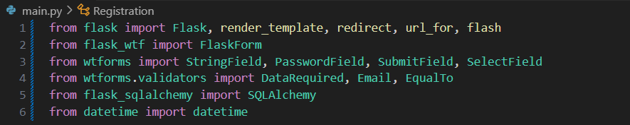

Flask App Configuration: The Flask app is initialized with some configurations. The SECRET_KEY is set for session security, and the SQLALCHEMY_DATABASE_URI specifies the location of the SQLite database file. Additionally, SQLALCHEMY_TRACK_MODIFICATIONS is set to False to disable unnecessary notifications.

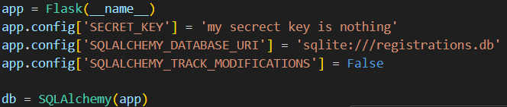

Database Model: The Registration class represents a database model for user registrations. It inherits from db.Model provided by SQLAlchemy. It defines fields such as id, full_name, email, password, destination, activities, and date_added.

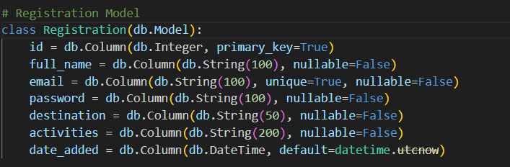

Registration Form Class: The RegistrationForm class defines a FlaskForm for user registration. It consists of fields corresponding to the Registration model, along with validators to ensure data integrity and validation rules.

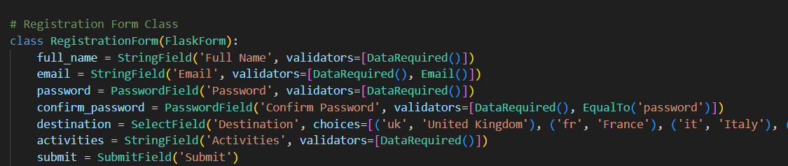

**Routes:**

Index Page: The root route (/) renders the index.html template.

Registration Page: The /registration route handles GET and POST requests. On GET, it renders the registration.html template with an instance of the RegistrationForm. On POST, it validates form data, adds a new registration entry to the database, and redirects to the /destinations route upon successful registration.

Destinations Page: The /destinations route renders the destinations.html template, which displays available travel destinations.

Other Routes: Additional routes (/trip_plan, /london_uk, /trip_plan2, /france, /form, /submission) are defined to render corresponding templates.

Error Handlers: Error handlers are defined for 404 (page not found) and 500 (internal server error) cases. They render custom error templates.

Database Creation: Inside the if __name__ == '__main__' block, the app context is created, and db.create_all() is called to create database tables before running the Flask app.

**Some photos from my website**

**Welcome page:**

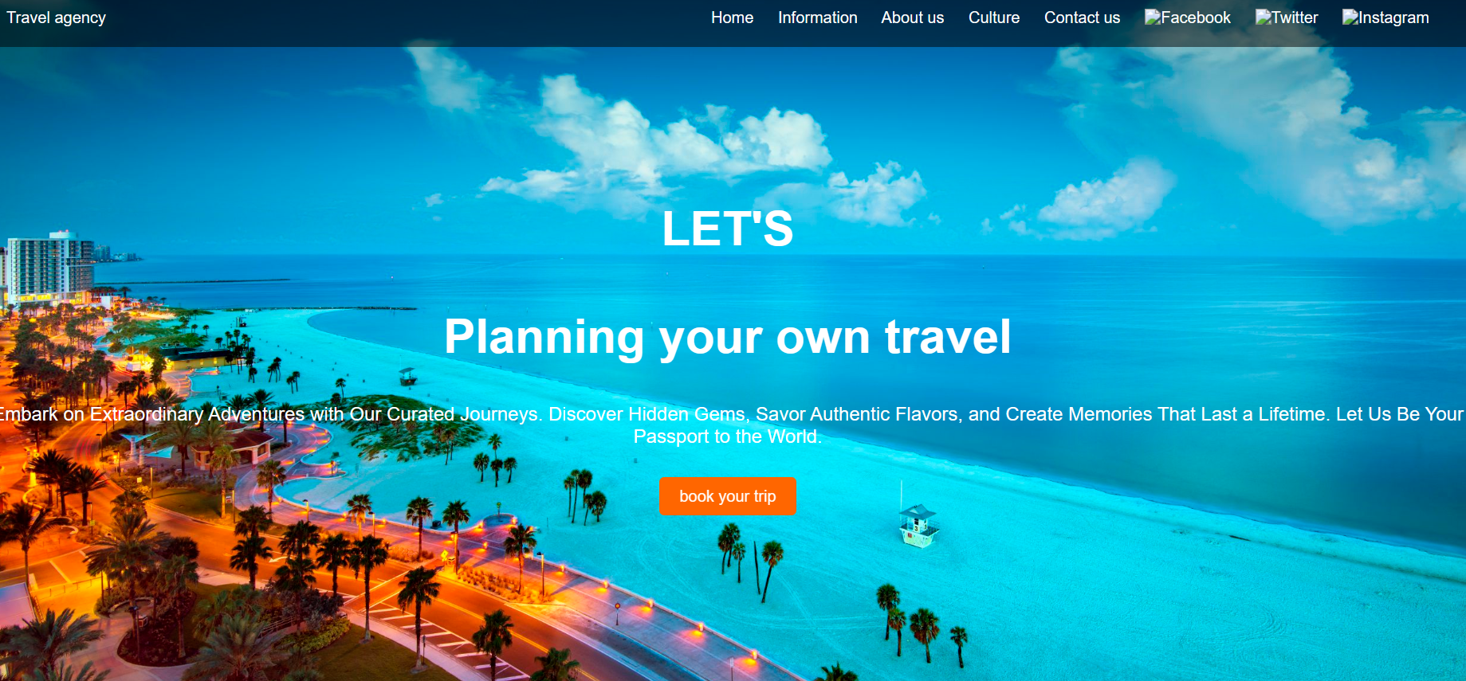

**Registration page:**

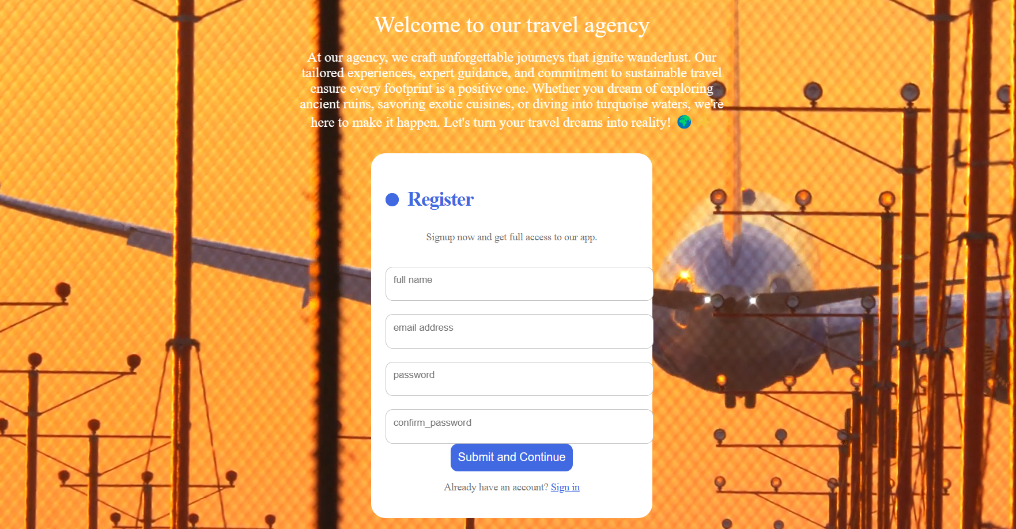

**destinations page:**

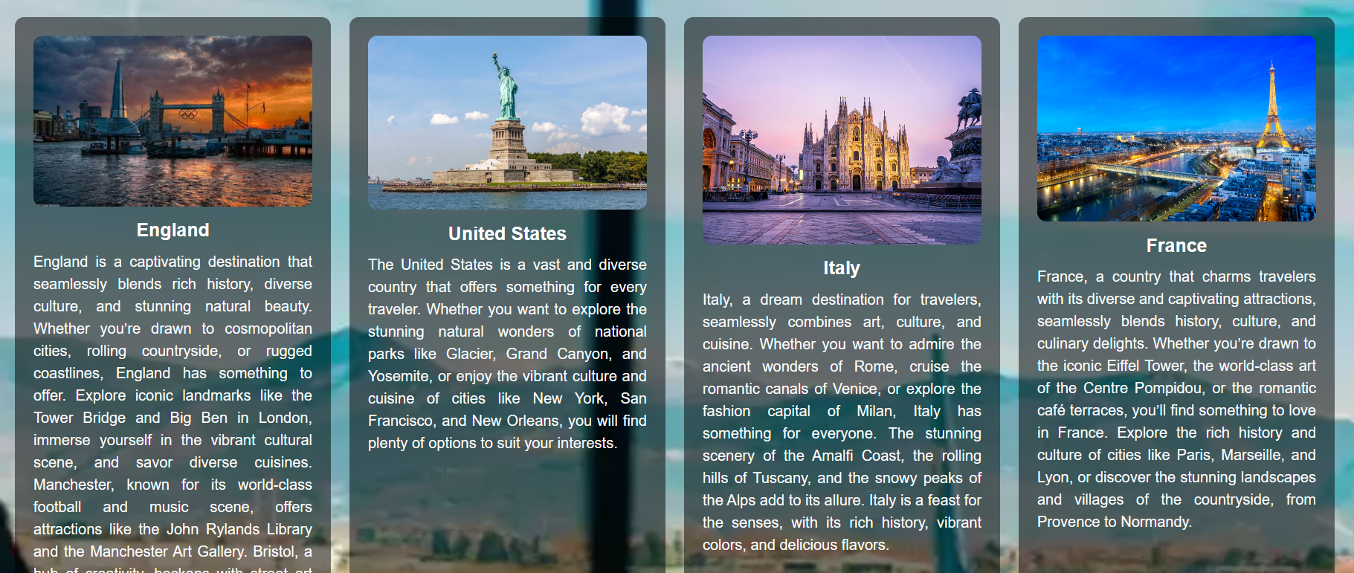

**Trip_plan page:**

By clicking on London’s photo it will redirect to trip_plan page

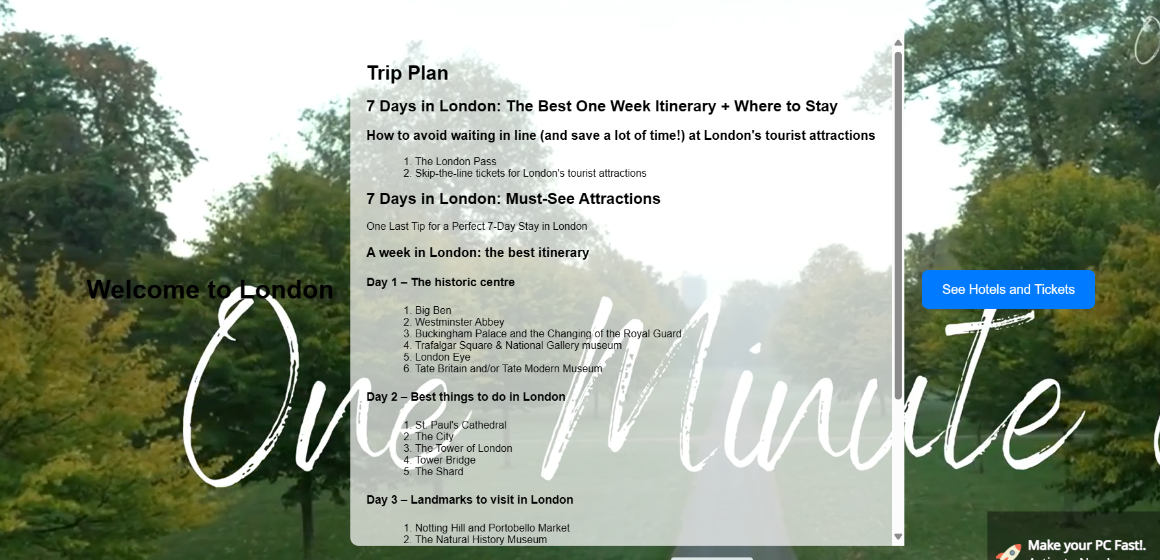

**London_uk page:**

By clicking on see hotels and tickets



**Trip_plan2 page:**

By clicking on France’s photo it will redirect to its trip plan

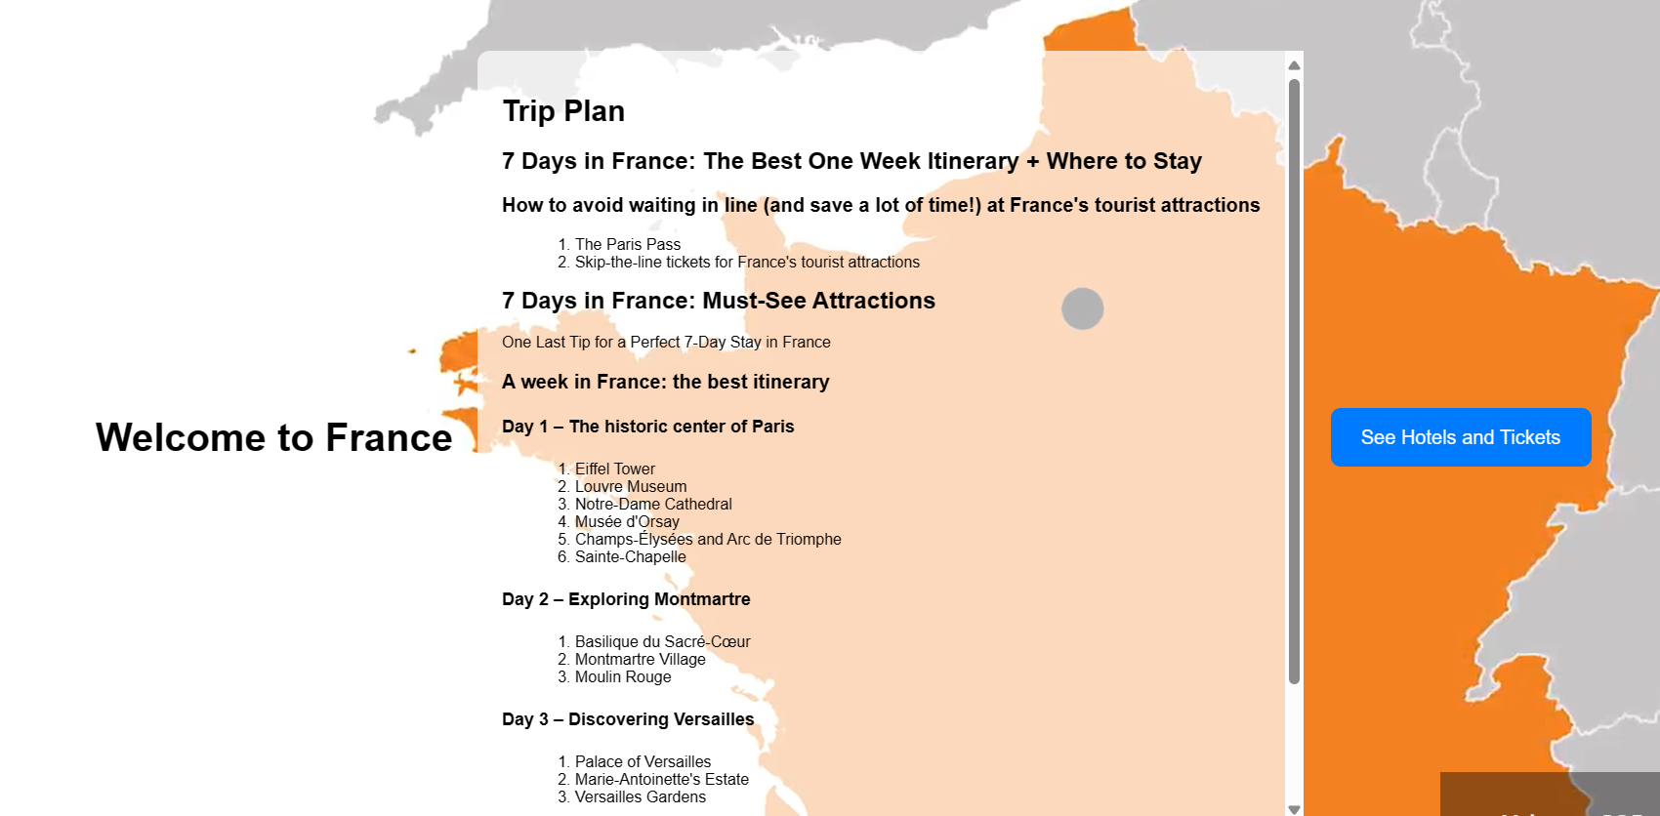

**france page:**

By clicking on see hotels and tickets

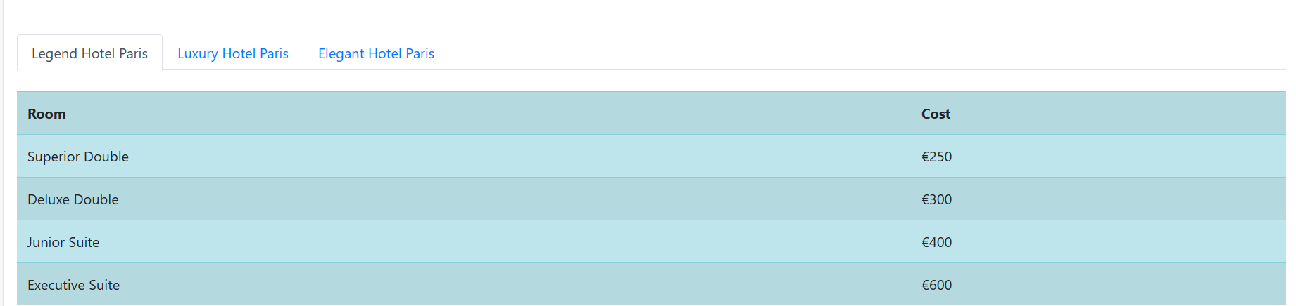

**form page:**

by clicking on choose your destination in the destinations page, it will redirect to the form page

